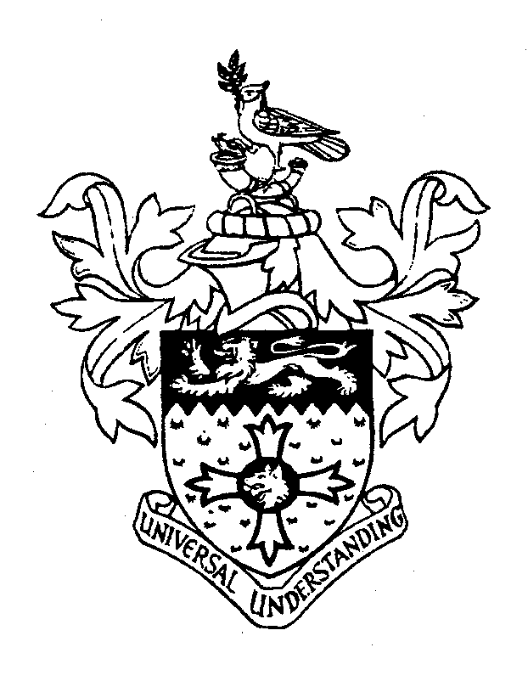 | CHARTERED INSTITUTE OF LINGUISTS  HONG KONG SOCIETY

40th Annual General Meeting

Time: 2:30 pm
Date: 16 November 2024 (Saturday)
Video conference via Zoom

Agenda

- Opening address
- Confirmation of minutes of the last meeting
- Matters arising from the 39th Annual General Meeting
- Confirmation of Auditor’s Report 2023–2024
- Chairman’s report for the year 2023–2024
- Election of Executive Committee members
- Any other business

